1 | Table as per given constraints.  Table : EMPLOYEE  Column Name Data Type Size Attributes  EMPNO Number 4 Primary Key  ENAME Varchar2 20 Not Null  JOB Varchar2 20  MGR Number 4  HIREDATE Date  SAL Number 10  COMM Number 7  DEPTNO Number 2 Foreign Key  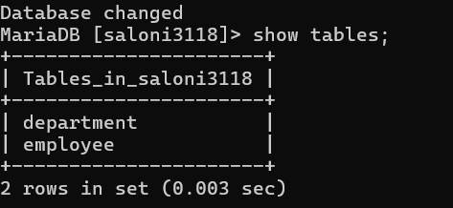  Table : DEPARTMENT  Column Name Data Type Size Attributes  Deptno Number 2 Primary Key  Dname Varchar2 15 Not Null  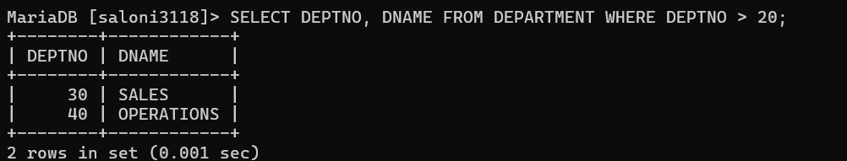  Values in the table.  EMPNO ENAME JOB MGR HIREDATE SAL COMM DEPTNO  7369 SMITH CLERK 7902 17-Dec-80 800 20  7499 ALLEN SALESMAN 7698 20-Feb-81 1600 300 30  7521 WARD SALESMAN 7698 22-Feb-81 1250 300 30  7566 JONES MANAGER 7839 02-Apr-81 2975 20  7654 MARTIN SALESMAN 7698 28-Sep-81 1250 1400 30  7698 BLAKE MANAGER 7839 01-May-81 2850 30  7782 CLARK MANAGER 7839 09-Jun-81 2450 20  7788 SCOTT ANALYST 7566 09-Dec-82 3000 40  7839 KING PRESIDENT 17-Nov-81 5000 20  7844 TURNER SALESMAN 7698 08-Sep-81 1500 0 30  7876 ADAMS CLERK 7788 12-Jan-83 1100 20  7900 JAMES CLERK 7698 03-Dec-81 950 30  7902 FORD ANALYST 7566 03-Dec-81 3000 20  7934 MILLER CLERK 7782 23-Jan-82 1300 10  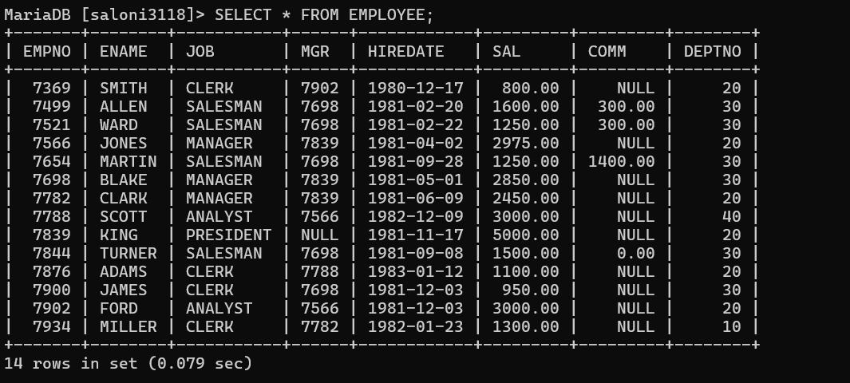  DEPTNO DNAME  10 RESEARCH  20 ACCOUNTING  30 SALES  40 OPERATIONS  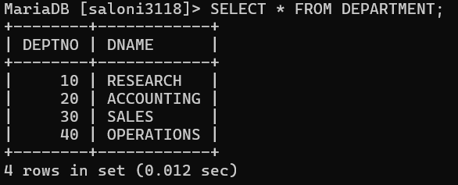  Perform following Query  - Create Employee_master table with data using Employee table.  - Delete all record into Employee_master whose DeptNo is 10  - Update 10% in his salary of DEPTNO 20 into Employee_Master.  - Alter SAL with size 10,2 in Employee_Master.  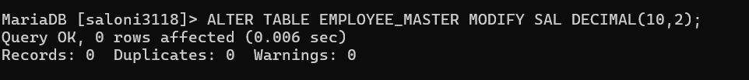  - Drop Employee_master Table.  